**Sapphire**

Sapphire is a clothing retail in Pakistan. It is a subsidiary of the Sapphire group of companies, it is a vertically integrated textile manufacturer that produces yarn, fabric and finished products. It has a strong brand recognition and market presence in Pakistan. The company has made investments in sustainable practices and product with its established online and offline retail channels.

**Objective**

Identifying 2-3 gaps of this business

**Current state:**

Sapphire is a well-known brand in Pakistan but currently they are facing some challenges due to their mismanagement in inventory control that leads to an adverse impact on the sales and customer satisfaction. Due to the lack of sustainable practices, the brands sustainability messaging is not consistently communicated to consumers, leading its impacts and dissatisfaction of consumers.

**Target State:**

The target state can be achieved with a more integrated inventory management involving some real-time analytics that actually maintains the level of stocks and integration of customer’s satisfaction for the overall growth of the product and the brand.

**Gaps identification:**

**Gap 1; Supply Chain and Inventory Management:**

**Current state:** Sapphire’s current supply chain is largely manual and heavily reliant on the traditional methods. Inventory management is a significant challenge leading to overstocking in some areas and stock out in others that affects the sale and customer satisfaction.

Target state: A fully automated and integrated supply chain that uses real time data analytics for demand forecasting, inventory management and distribution.

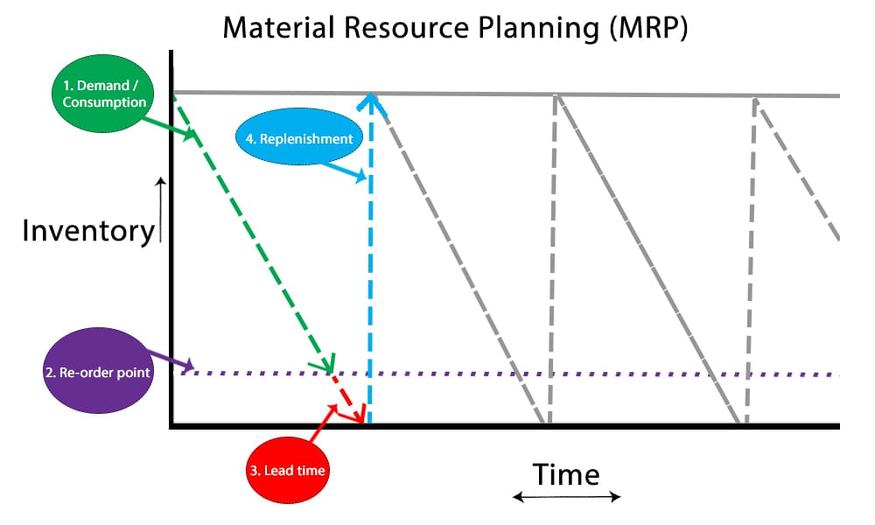

**Gap 2: Sustainability Practice:**

**Current State:** While Sapphire has made a lot of progress in its sustainability, the efforts are somewhat fragmented and are not fully integrated across all business operations. The brands sustainability message is not consistently communicated to consumers, limiting its impact.

**Target State:** Full integration of sustainability into every aspect of business, from raw material sources to manufacturing, packaging and retail. Additionally, a robust marketing strategy that highlights these efforts to enhance brand image and consumer loyalty.